Example
Anne Turner
Web Media Management Assignment

Using Twitter to Find More Customers for Clothing Retail Store

Introduction
After researching several social media platforms, Twitter appears to be the best one to attract more customers to our clothing retail, and Tweet Deck is a management program that would enhance our presence on Twitter and make answering questions easier. Twitter is widely used for advertisement of clothing brands, and our competitors already have a presence there. Besides boosting our advertising to a new audience, using Twitter and Tweet Deck will give us the opportunity to interact with our customers.

Twitter Profile
Twitter was created in 2006. There are over 330 million active users—the majority of which reside in the United States, Japan, and the United Kingdom. The demographics for the social media site are varied. Most users are age 18-29 or 30-49. Twitter appears to be recruiting larger numbers of users than other social media sites, specifically across a wide age range. Since our customers vary in age from 18-45, this appears to be a good platform to reach multiple age groups on.
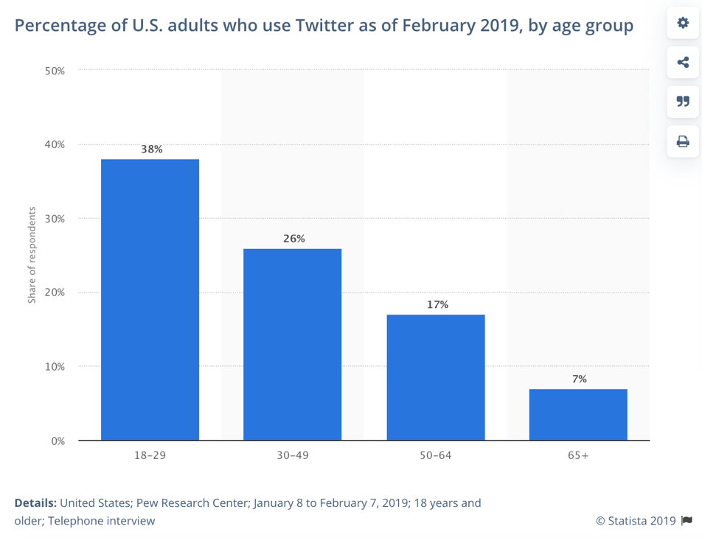

Benefits of Twitter
There are many benefits to using Twitter for business. Twitter is accessible by both users and non-users, which makes it an ideal social media platform for our retail, as it will also show up in search engine results.
Twitter encourages paid advertisements, which can be used effectively to direct people to our clothing website. Organic advertising is also an option, given the hashtag feature. Hashtags are used in the same way that a word cloud is used: to keep similar subjects in the same thread.
Another great benefit of Twitter is the ability to interact with followers through private message, tweets, replies, and hashtags. This would show our brand as being active and available for questions. We can also interact with other brands and be part of the conversation about clothing retail.

Tweet Deck Profile
To manage Twitter, the best solution I found was a social media content manager called Tweet Deck, which is actually run by Twitter. Tweet Deck provides a columned screen where you can view the homepage, messages, and other customized columns such as hashtags and mentions. Tweet Deck was launched in 2008 as an independent app and later acquired by Twitter and integrated into its current system as an application. There have been multiple releases of updates throughout the years.

Tweet Deck Benefits
Tweet Deck is a great tool to manage all the above-mentioned features of twitter, but in one place. There is less time spent scrolling through messages, then clicking to a load a new page and tweet. All of the social media management can be done in one place. Another great feature of Tweet Deck is being able to add multiple team members. If our social media profile grows quickly, we may need additional member to manage it.
One important note about Tweet Deck is that it is not a third-party management system, which makes it more secure to use.

Example
Below is a screen shot showing the Tweet Deck interface.

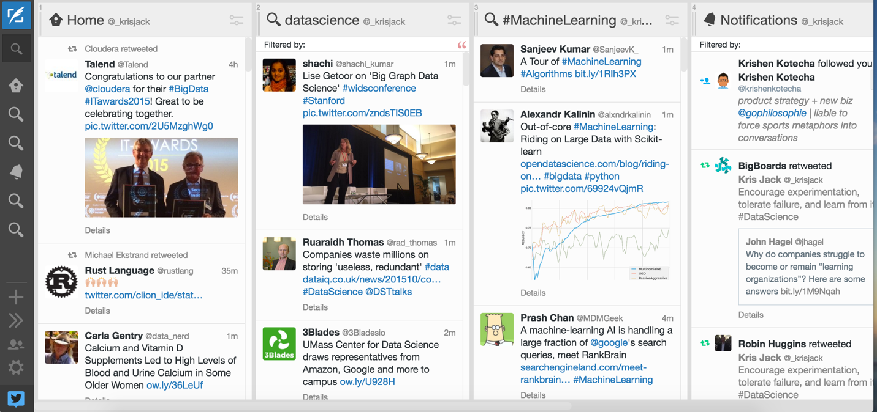
(Source: Kris Jack)

Conclusion
With both Twitter and Tweet Deck to manage it, I can see this being a great resource for our small clothing company to expand our reach. With the many features that Twitter has, we can effectively communicate our brand’s message to a broader audience. Using Tweet Deck to manage Twitter can organize our social media priorities and save our social media specialist time as they answer questions and schedule content.

Sources

Jack, K. (2015). Retrieved from https://krisjack.files.wordpress.com/2015/11/screen-shot-2015-11-02-at-19-47-59.png

Pew Research Center. (April 10, 2019). Percentage of U.S. adults who use Twitter as of February 2019, by age group [Graph]. In Statista. Retrieved October 21, 2019, from https://www.statista.com/statistics/265647/share-of-us-internet-users-who-use-twitter-by-age-group/

Twitter. (April 23, 2019). Number of monthly active Twitter users in the United States from 1st quarter 2010 to 1st quarter 2019 (in millions) [Graph]. In Statista. Retrieved October 21, 2019, from https://www.statista.com/statistics/274564/monthly-active-twitter-users-in-the-united-states/

